Java Game Suite Project Design

Revision 2

CMSC 495 6382

September 11, 2021

Group Charlie

Sherry Funches, Oyewole Sanusi, Janee’ Jones, Wayne Mack, Jeffrey McGlinn

## Revision History

|  |  |  |  |
| --- | --- | --- | --- |
| **Revision Number** | **Date** | **Description** | **Name** |
| 1 | 9/7 | Creation of Google Doc, outline | Oyewole |
| 2 | 9/11 | Creation of Sequence Diagrams | Jeff |
|  |  |  |  |
|  |  |  |  |

## I. Class Diagram

## II. Sequence Diagrams

**Start-up Scenario:**

**Description:** User starts up the application.

**Pre-Condition:** No hardware or system failure that would hinder the application occurs.

**Post-Condition**: Application starts without hardware or system failure.

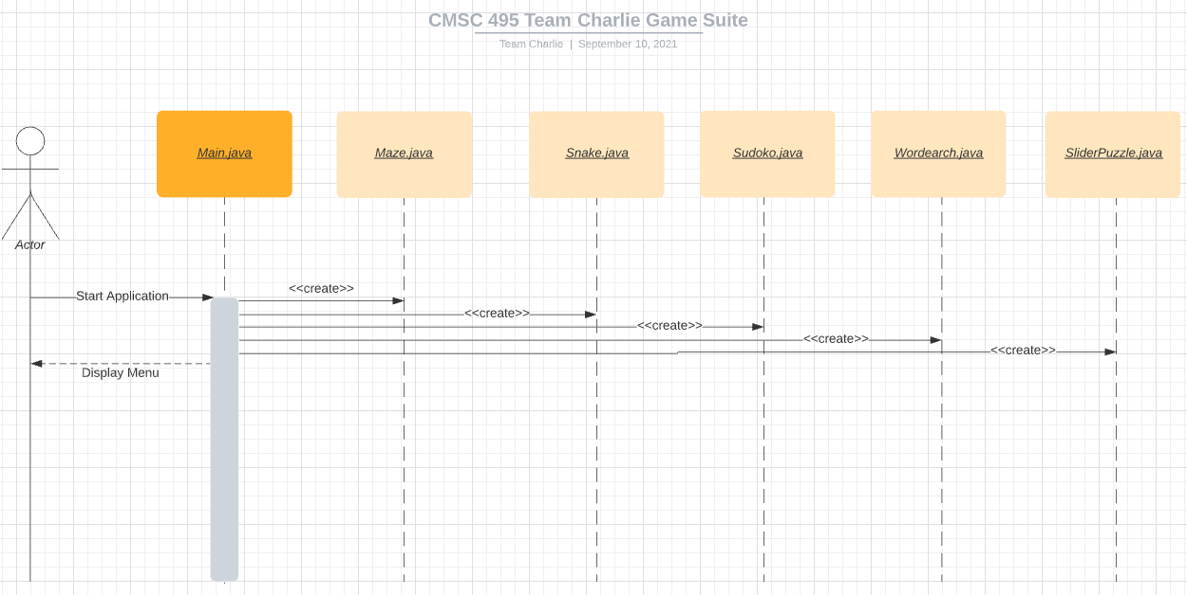

**Shut-down Scenario:**

**Description:** User exits the program.

**Pre-Condition:** Program has been running successfully without crashing.

**Post-Condition**: Program is terminated, and all objects are deconstructed.

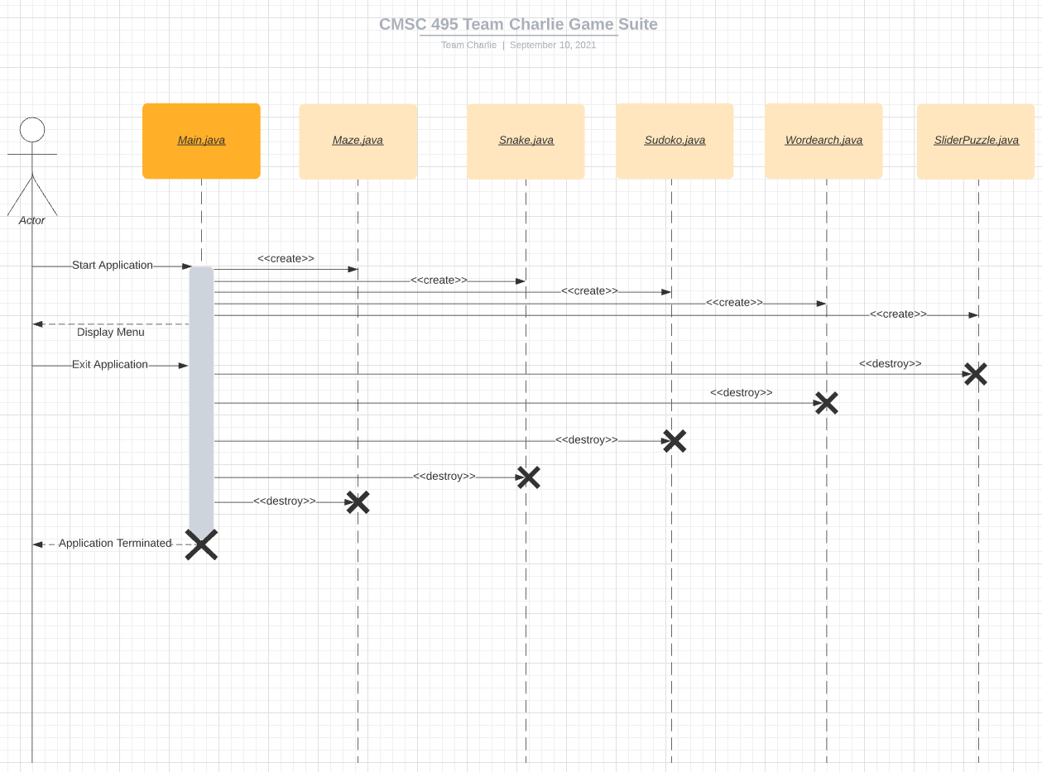

**Normal Operation Scenario:**

**Description:** User starts application and selects games from the menu.

**Pre-Condition:** Program has been running successfully.

**Post-Condition**: The program displays and exits each game that has been selected without hardware or system failure.

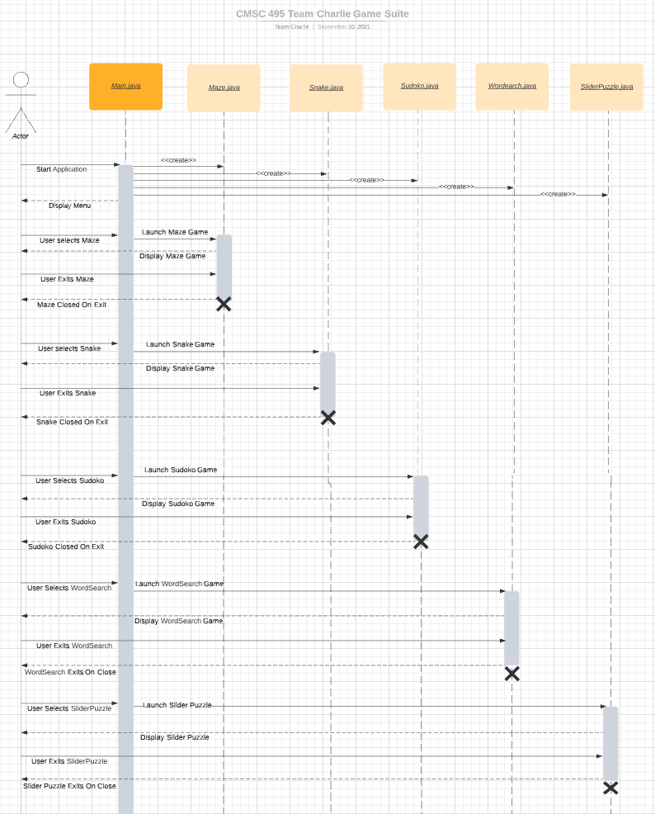

**Error-Handling Scenario 1:**

**Description:** User starts application, launches the slider puzzle game, and selects a new puzzle.

**Pre-Condition:** Program has been running successfully.

**Post-Condition**: If a puzzle image file is not found, handle exception, and inform the user with a message:

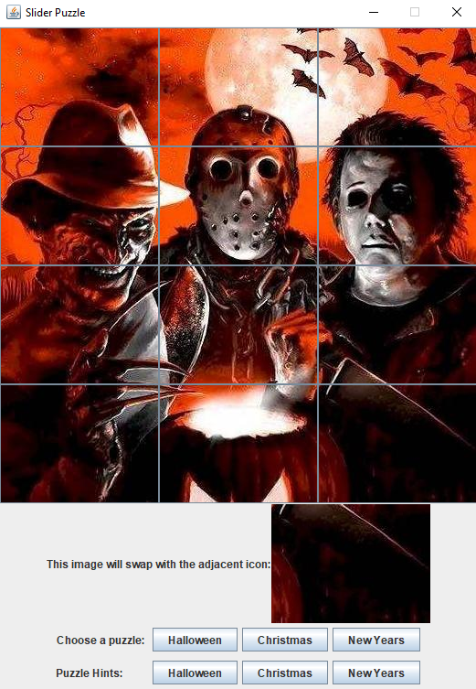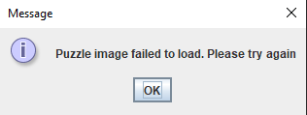

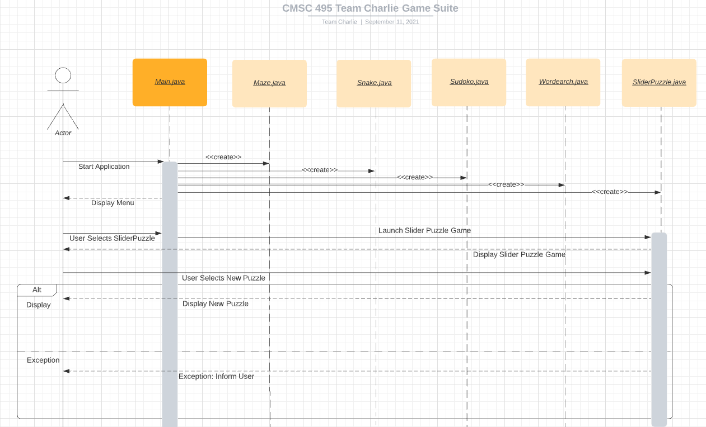

**Error-Handling Scenario 2:**

**Description:** User starts application, launches the word search game, and attempts to load a new puzzle file.

**Pre-Condition:** Program has been running successfully.

**Post-Condition**: If a puzzle file fails to load, handle exception, and inform user:

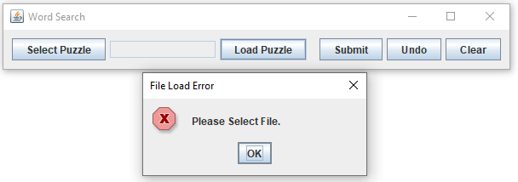

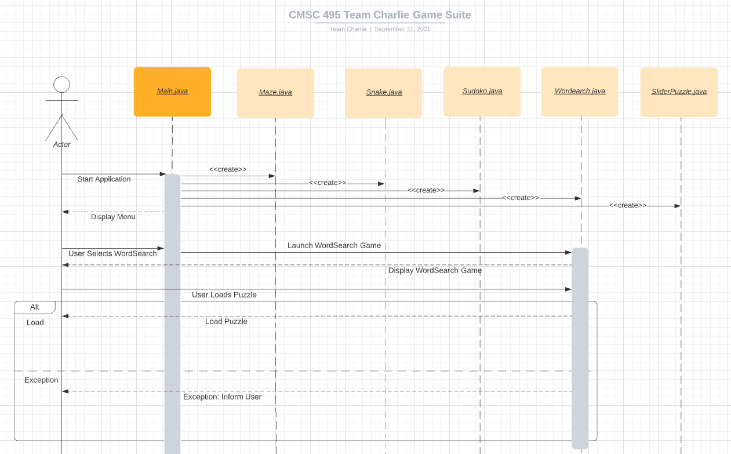

**Error-Handling Scenario 3:**

**Description:** User starts application and attempts to load a Sudoku puzzle.

**Pre-Condition:** Program has been running successfully.

**Post-Condition**: If Sudoku fails to load, handle exception, and display a message containing the line number and class name where the exception occurred using .printStackTrace():

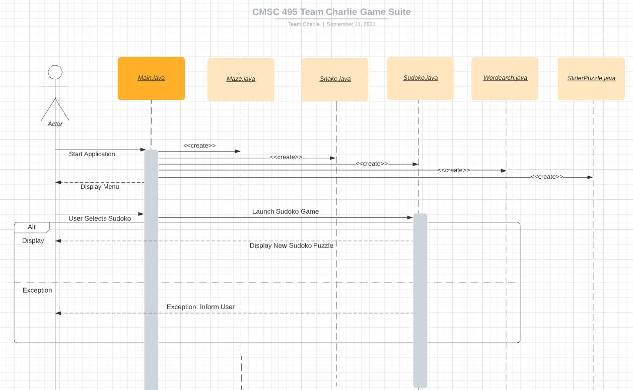

## III. Pseudo Code

## IV. Unresolved Risks and Risk Mitigations

## References:

Creately. (2021). Sequence diagram tutorial – complete guide with examples. Retrieved from

https://creately.com/blog/diagrams/sequence-diagram-tutorial/